**Subject: Data Communication Laboratory**

**Activity 1: Setting up Data Communication Facility - Design an Internet/Computer/Gaming Shop**



**Submitted By:**

**Mascardo, John Razeer**

**Doblas, Ken Henry**

**Abeleda, Kyle**

**Ydian, Rochell**

**Barcela, Bernadette**

**Savella, Jerwell**

**Submitted To:**

**Engr. Jaime Licuanan**

**Objective:** Apply the concept of data communication to design a facility that illustrates connectivity, network components, and infrastructure

**I. Introduction**

- Name of the Shop *QuantumTech Hub*

- Description *"Elevating your tech experience"*

- Identify Location *Rural Areas*

**II. Services Offered**

Where we pride ourselves on delivering top-notch services tailored to meet your digital needs. With a steadfast commitment to excellence, we offer a comprehensive array of solutions designed to enhance your computing experience. First and foremost, our printing services stand as a testament to our dedication to convenience and efficiency. Whether you require crisp documents for professional presentations or vibrant prints for personal projects, our state-of-the-art printing facilities ensure exceptional results every time. Moreover, we specialize in providing high-quality computing experiences for both leisure and professional endeavors. Dive into seamless surfing sessions with our meticulously curated selection of high-speed internet solutions, guaranteeing smooth browsing and uninterrupted connectivity. For the avid gamer seeking unparalleled performance, our cutting-edge gaming setups are engineered to deliver immersive experiences with stunning visuals and responsive gameplay. At our computer shop, we prioritize customer satisfaction above all else, striving to exceed expectations with every interaction. With a team of knowledgeable experts on hand to offer guidance and support, rest assured that your computing needs are in capable hands. Experience the difference at our computer shop, where excellence is not just a goal, but a standard.

**III. Technical Parameters**

**1. Network Diagram and Connections**

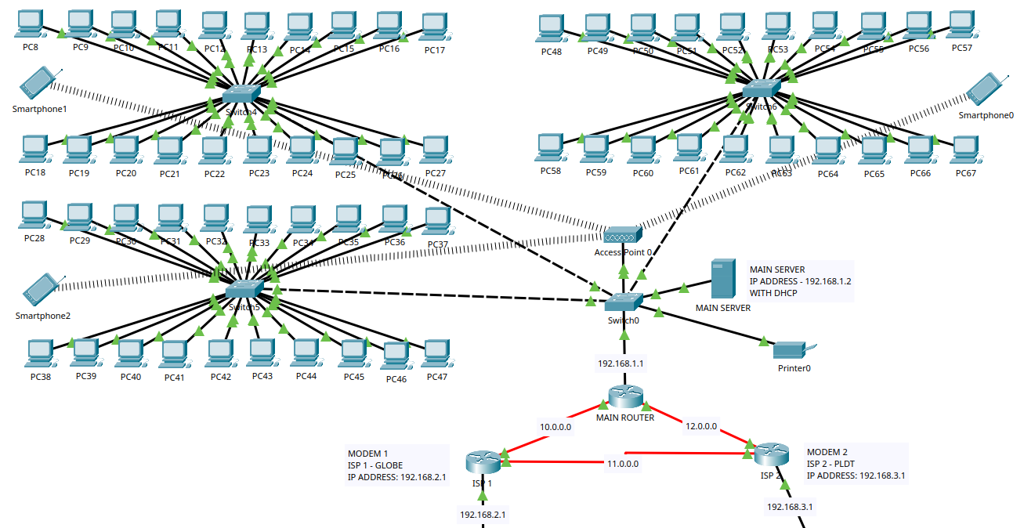

The Network topology we have come up with can be seen above and designed using Cisco Packet Tracer. It consists of 60 Computers, 4 switches, 1 Access point for Wifi connectivity, a printer, a router, and 1 Server. The main server will be the one responsible for monitoring each of the machines for the whole network, it’s also the one responsible for allocating the configuration needed for each one of our machines, devices, and such that will be tackled on *IP Address Deployment* of this project. The first connection is established from our server to ‘switch0’, and that main switch will then be connected to submodule switches, ‘Switch1’, ‘Switch2’, and ‘Switch3’, each of those submodule switches will only be connected with 20 computers each. After connecting each of the nodes to our switches, we will then configure our Router and implement a simple dynamic routing protocol using RIP (Routing Information Protocol).

* Details on Setting Up our Network:
  + **Hardware/Physical Setup.**
    - Setting up the equipment and devices in our Network on the hardware side is quite simple, We have 4 switches in total, and we connected 20 computers to each of them in 3 of our switches.

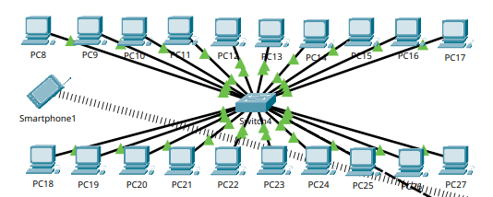

* + - All of those 3 switches will then be connected into 1 base switch Named “Switch0” where the Router, Server, Printer, and Access point are connected.

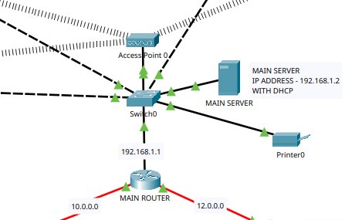

* + **Wireless Access Point Setup**
    - For the access point, We set the Authentication to be the standard on ‘WPA2-PSK’, We set the SSID to “QuantumTech” and PassPhrase to “quantumtech”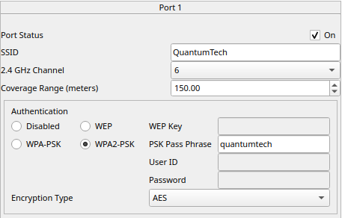
    - Connecting our Wireless devices to the access point. Go to the Wireless 0 of the devices and type the SSID and Password of the AP, as you can see it will then be connected to the device and will automatically give an IP Address and subnet mask that we set up on our DHCP server.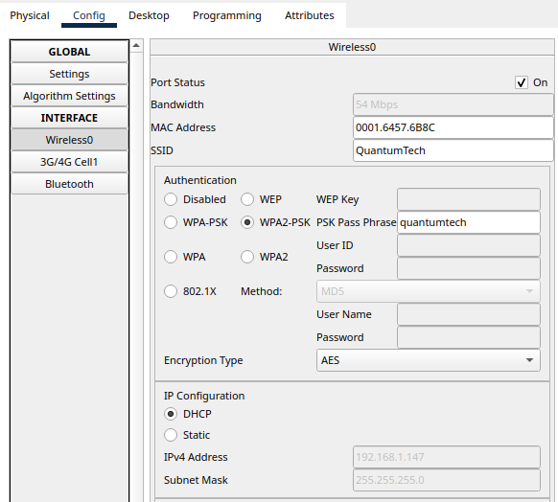

Connection is established from the access point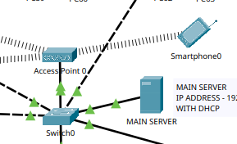

* + **Routing Protocol Setup**
  + **Router Setup.**
    - Setting up our router to connect to our ISP. We use a simple routing protocol called RIP(Routing Information Protocol) just to test if we can connect our Inside network to the outside (INTERNET).

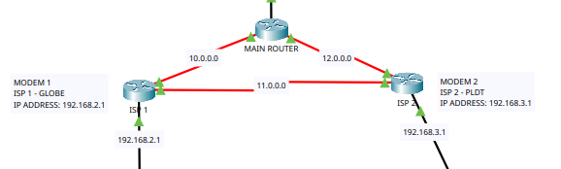

* + - In the CLI Environment, we configured all the parameters for ports and allocated each of the gateway its own IP Address.

Configuration for our “MAIN ROUTER”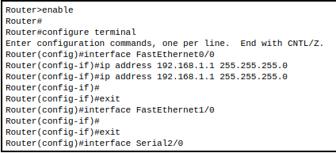

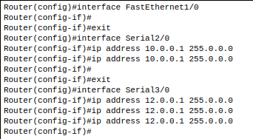

To test, if our network can connect outside, We set up RIP in the terminal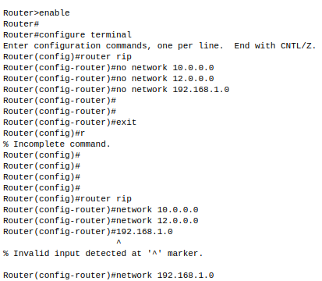

To check if our router can actually communicate with the “Outside Network or the ISP’s Modems” we type “show ip route” and as you can see it can visually see the given addresses for testing which are the 12.0.0.0 and 10.0.0.0

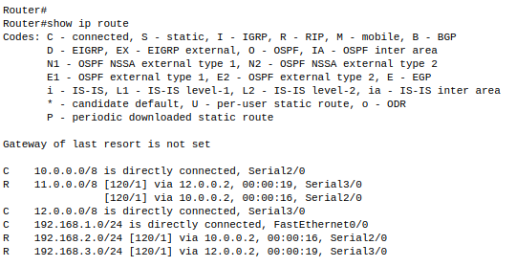

**4. Physical Diagram of the shop, Electrical Layout and Cabling**

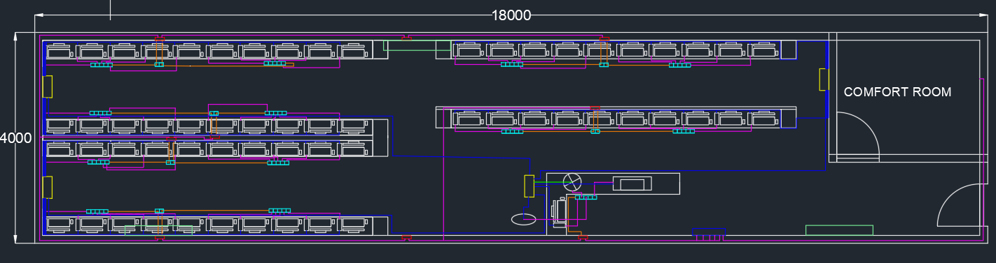

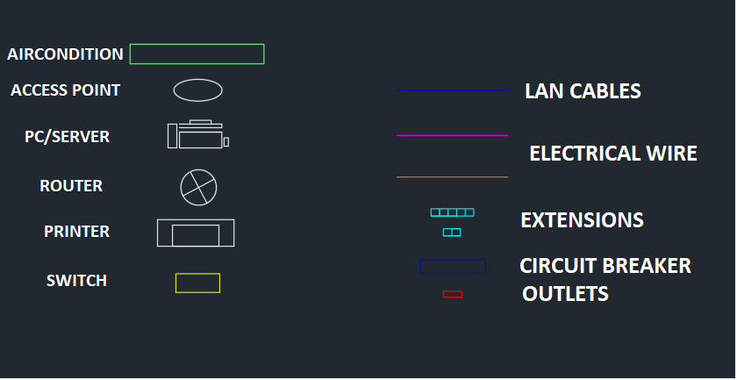

The figure above shows the electrical layout plan and cabling of the shop. The area of the shop is 72 sqm. It consists of extensions, routers, printers, servers, switches, and PC units. Each of the twenty PC units is connected to one switch, and each switch and the server are connected to the router. Each of the five PC units is connected to an extension, and each extension has a main extension to avoid overloading. The purpose of the generator is to provide an alternative power source when there is a power outage.

**5. IP Address Deployment**

For the Deployment of IP Addresses in our Network, We implemented a DHCP server or Dynamic Host Configuration Protocol. Since this is a real business that will be running for a lot of hours, we need to maximize our time to its full potential, So implementing an approach that will minimize our time on configuring and maintaining each of the machines will be much better and we can allocate our time on running the business.

Why DHCP? The requirement number of machines that this network needs is 60 clients, we need to add 1 for the main server including other devices that need to be configured one by one, so if we implement IP Address allocation manually to all of those machines and devices it will be time-consuming, error-prone and not practical. And also, if the owner plans to add more computers in the future configuration needs to be applied in those as well. So we decided to use this approach in the deployment of IP Addresses.

When a device joins a network, it can use DHCP to request an IP Address from a DHCP Server, which then assigns an available IP Address to the device. Another good thing about this is it can also provide other configuration information such as the subnet mask, default gateway, and DNS Server addresses however those will not be tackled in this project.

Implementation:

* After setting up your network topology, we will configure the server that we placed.

Select the ‘Server’ and the first thing we will do is to assign a static IP Address to it. A DHCP server must have a configured IP address so that it can know which scopes are locally attached to physical interfaces, and which Scopes can only be served via a DHCP relay.

We assigned the DHCP or the Main server to be ‘192.168.1.2’ with a class C subnet mask. We did that because we want to assign the ‘192.168.1.1’ to be our Default gateway

Connect the server into the switch Assign Static IP address to the Main/DHCP Server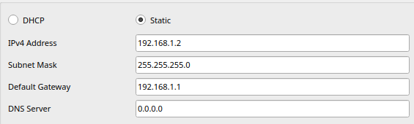

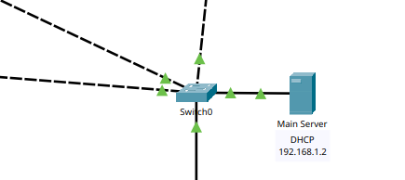

* After assigning the IP Address to the server, Go to the DHCP option on the right-side menu and turn the service ‘On’. We named our Server Pool ‘DHCP MAIN SERVER’, The default gateway we are using is ‘192.168.1.1’, at this point, we don’t have to assign a specific DNS server as it’s configuration so we will leave it as it is. After that, We set the Starting IP Address to be ‘192.168.1.5’ we did that because we already assigned the 1.2 and 1.2 statically on our server and as our default gateway. We set the maximum number of Users to be 200 just in case we will add an additional devices and machines to our network. Click ‘Add’ and ‘Save’ the Configuration.

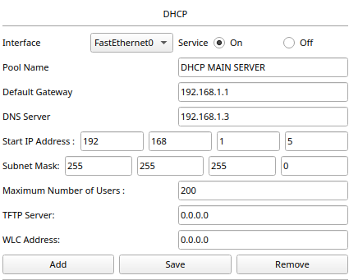

* After that, we can go to one of our machines and request an IP address to our DHCP Server. Click one of the computers and go to ‘IP Configuration’, We will not manually allocate an IP Address.

Click the DHCP to request the 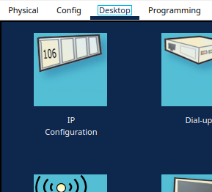

the configuration needed for this machine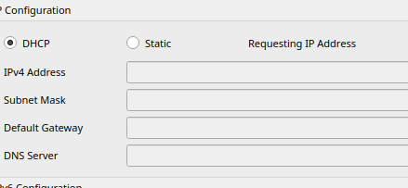

After obtaining the configurations, It will tell that the request is successful 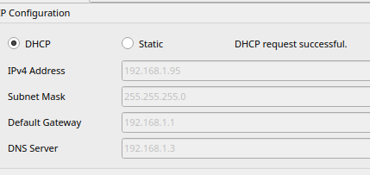

* After requesting the configuration from our DHCP server in all of our machines, we will check if the computers are connected to each other and actually establish a ‘Local Area Network’. We will try to ping PC Number 8 and PC Number 60.

PC 8 PC 60

IP Address: 192.168.1.19 IP Address: 192.168.1.26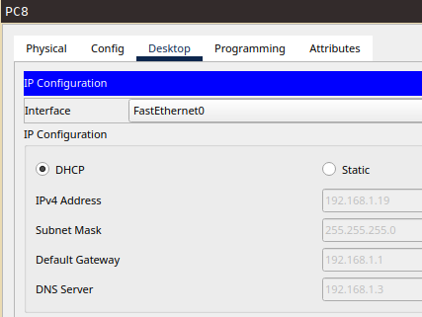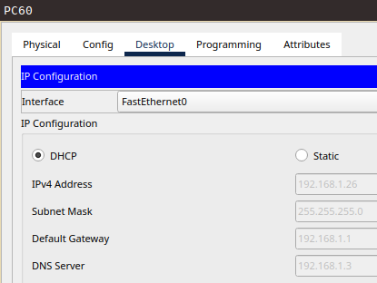

Ping from PC 8 to PC 60 Ping from PC 60 to PC 8 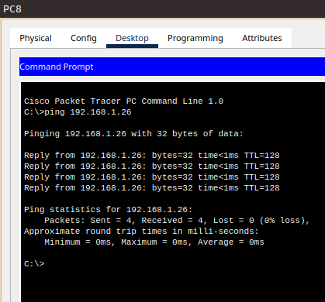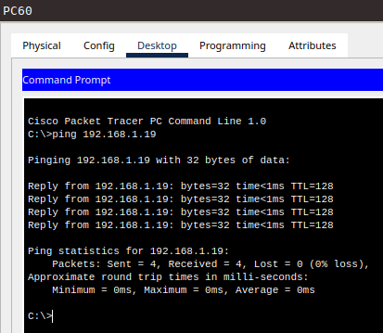

Testing the local area connection one more time to see if it actually works using a simple PDU From PC 8 to PC 9 and vice versa. From the result of our testing, we have seen that the local area network of our internet cafe is working properly and the machines are actually connected with each other, This is by just configuring our DHCP, and automating the allocation of the IP Address.

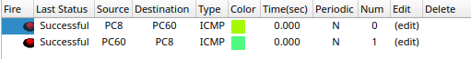

**6. ISP Consideration and Bandwidth Usage**

We have picked 2 ISP for this project, ***PLDT fibr plus plan 2399 speed 400mbps*** and ***Converge Fiber X3500 speed 800mbps***.

For Dual ISP Failover, We used a router that is capable of Multi-WAN setup, We used ***TP-Link ER605 Omada*** as our Main Router and for convenience, it’s easy to set up because of its Graphical User Interface where you can configure it.

The said router also has a built-in Load balancer where it can Allocate the bandwidth from the two ISP’s, and It will automatically decide which Connection it will use from a request and will allocate the necessary bandwidth needed when packets are requested.

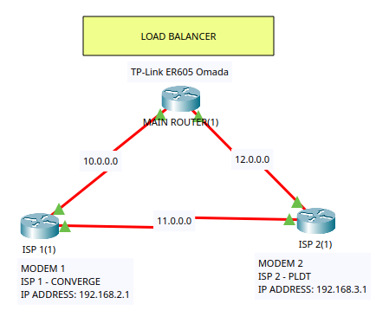

* Testing our Network connections.

Connections: 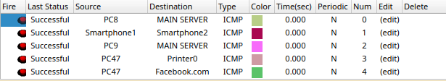

Computer (PC8) to Main Server

Smartphone to smartphone using WiFi

Computer (PC9) to Main Server

Computer (PC47 to Printer

Computer (PC47) to internet facebook.com

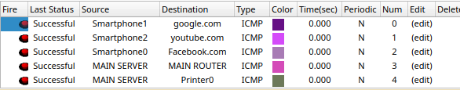

Connections:

Smartphone to google.com

Smartphone to youtube.com

Smartphone to Facebook.com

Main Server to Main Router

Main Server to Printer

**IV. Devices and Specs**

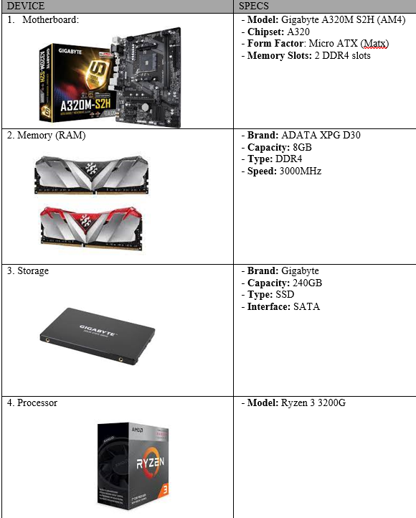

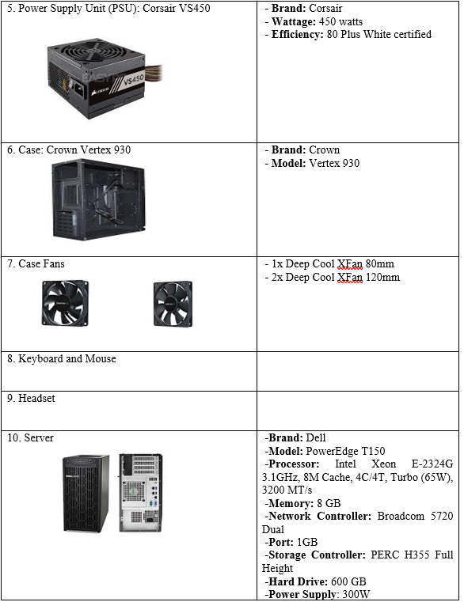

**V. Costing and ROI**

**COST**

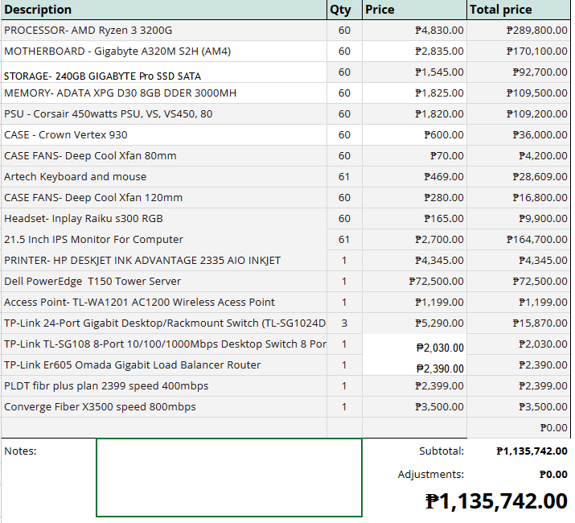

**ROI**

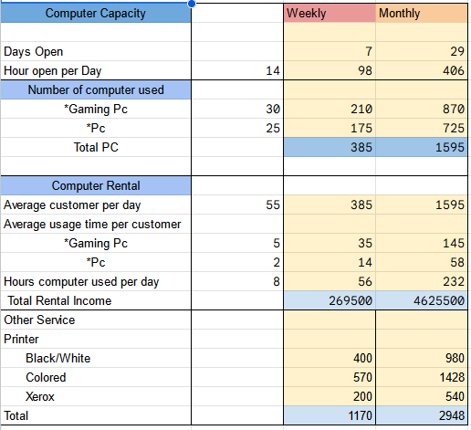

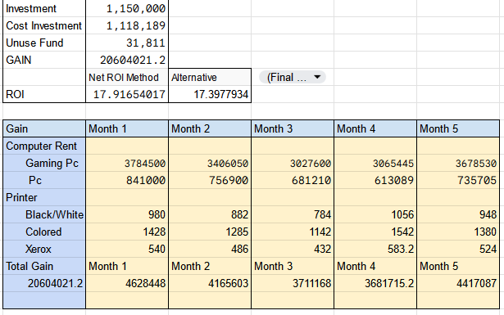

**VI. Recommendation and Conclusion**

**Recommendation:**

To ensure QuantumTech Hub's profitability and leadership in the industry, it's recommended to optimize technical infrastructure, diversify service offerings, prioritize strategic location, focus on customer satisfaction, and embrace continuous innovation. These strategies will drive sustained growth and profitability for the business.

**Conclusion:**

In conclusion, QuantumTech Hub offers unmatched technical design, outstanding service, and a dynamic customer experience that raises the bar for internet, computer, and gaming venues. Through the implementation of innovative infrastructure, broadening its range of services, and upholding a client-focused philosophy, QuantumTech Hub not only fulfills but is beyond consumer expectations, resulting in increased profitability and solidifying its position as the preferred destination for digital enthusiasts. In the ever-changing digital market, QuantumTech Hub is positioned for continuous success and expansion thanks to its inventive attitude and dedication to excellence.